**Hospital Management Analytics**

1.Fetch all patient details who registered in the last 30 days.  
Query:

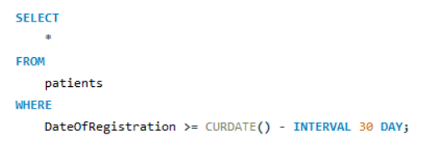

Result:

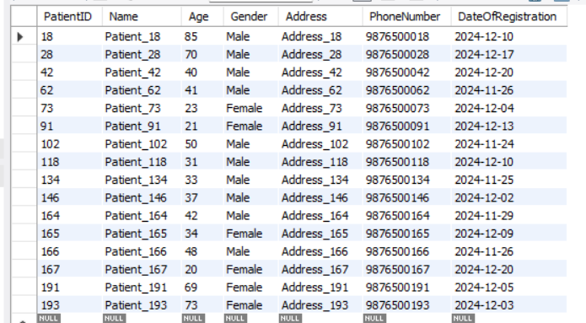

2.List all appointments for a specific doctor in a given date range.

Query:

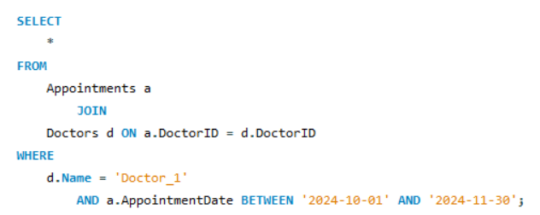

Result:



3.Identify the doctor with the most appointments in the last month.

Query:

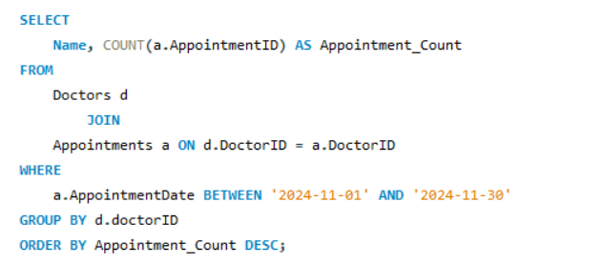

Result:

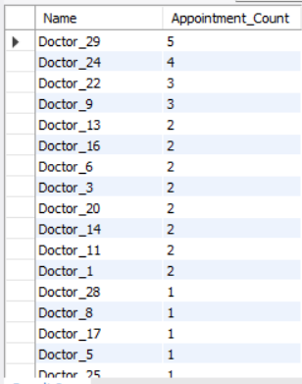

4.Calculate the total revenue generated by the hospital in the last quarter.

Query:

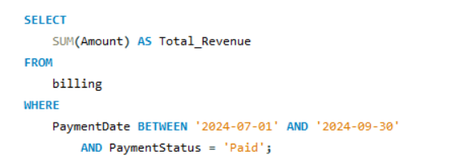

Result:



5.Find patients who have missed or cancelled more than 1 appointments.

Query:

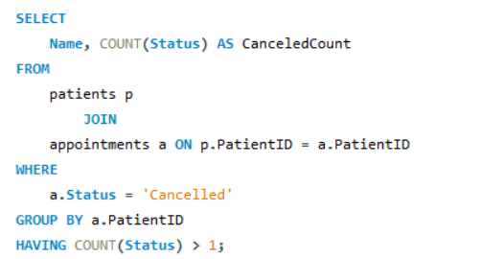

Result:

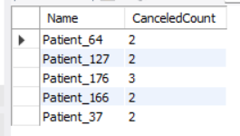

6.Determine the most common diagnosis provided by each doctor.

Query:

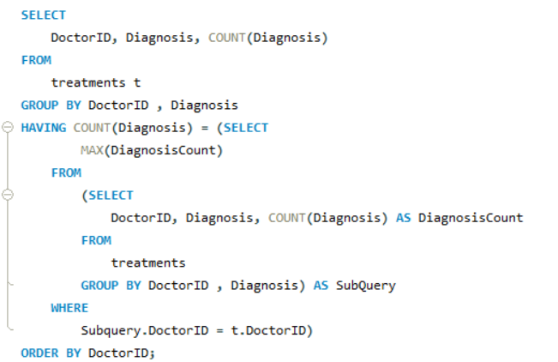

Result:

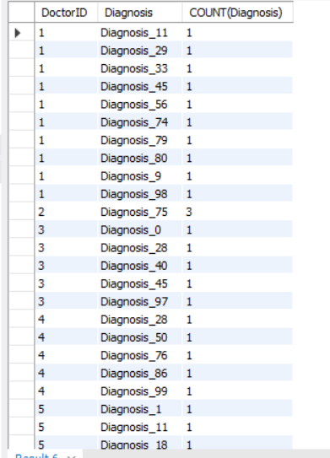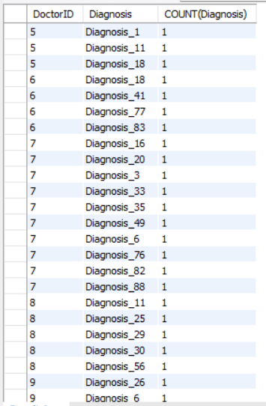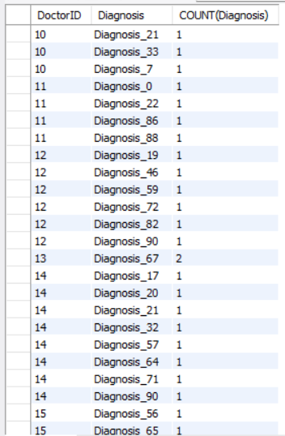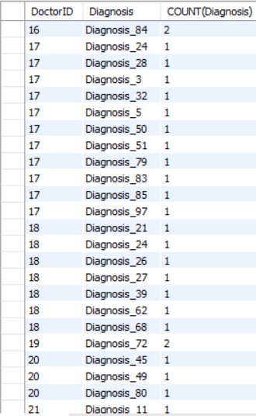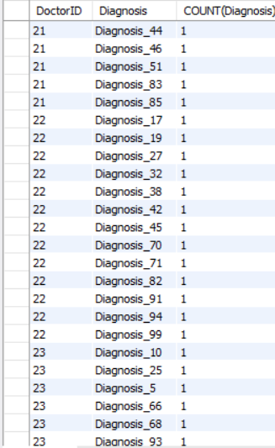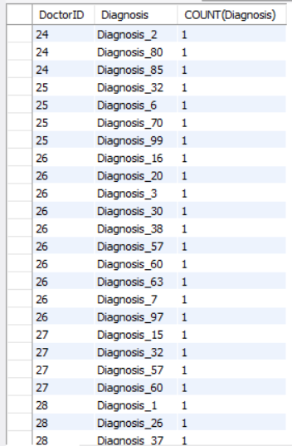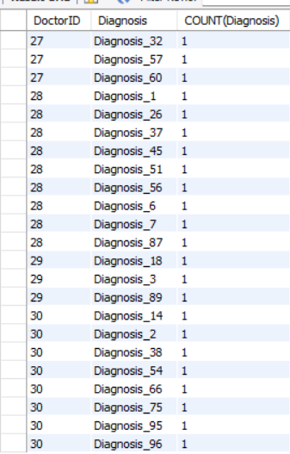

7. Generate a monthly revenue breakdown by doctor specialty.

Query:

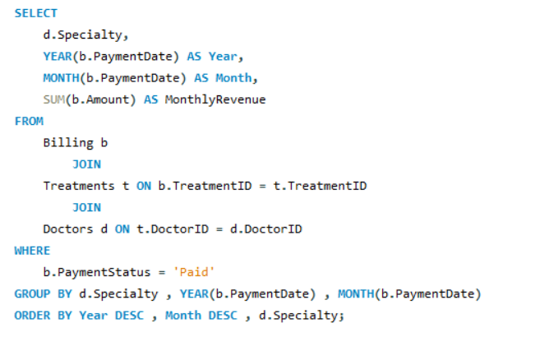

Result:

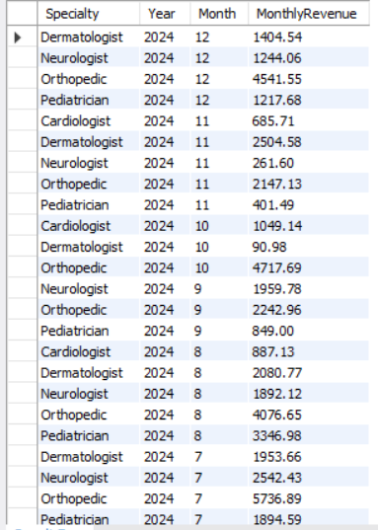

8.Analyze peak hours for appointments and suggest time slots for more efficient scheduling.

Query:

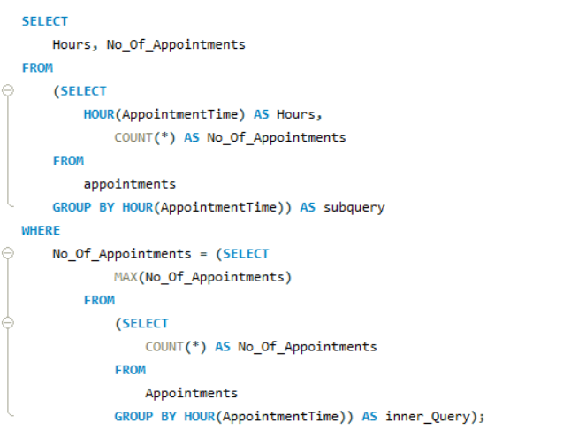

Result:

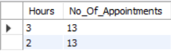

**-- DESCRIPTIVE ANALYSIS:**

-- 1. A Total of 20 PATIENTS REGISTERED IN THE LAST 30 DAYS.

-- 2. A TOTAL 3 APPONITMENTS HAD REGISTERED FOR DOCTOR_1 IN BETWEEN '2024-10-01' AND '2024-11-30'.

-- 3. DOCTOR_29 HAVE THE MAX [5] OF APPOINTMENTS IN THE LAST MONTH.

-- 4. A REVENUE OF ₹29462.92 WAS GENERATED IN THE LAST QUARTER.

-- 5. OVERALL, 5 PATIENTS CANCELLED THEIR APPOINTMENTS MORE THAN 1 TIME.

-- 6. DIAGNOSIS_75,67,72,7,84 ARE MOSTLY USED BY DOCTORS.

-- 7. 2PM AND 3PM HAVE MORE APPOINTMENTS COMPARING TO OTHER TIMINGS.